Circular Decomposition

Definition
# Source: AI Source: Provided by: [Data Path: Persons Table -> ID Column: 1, Name_En Column: Motasem Essam] -> From: [ChatGPT] on [7/25/2026]
Circular Decomposition is a method of dividing a geometric figure, especially a circular region or a figure containing curved boundaries, into smaller regions using circles, circular arcs, radii, diameters, chords, or other circular elements.
The resulting regions may be circular sectors, semicircles, circular segments, annular regions, or combinations of curved and polygonal shapes. Circular decomposition can be used to calculate areas, study geometric relationships, and simplify complex figures.

Simple Definition
# Source: AI Source: Provided by: [Data Path: Persons Table -> ID Column: 1, Name_En Column: Motasem Essam] -> From: [ChatGPT] on [7/25/2026]
Circular Decomposition is dividing a geometric figure into smaller parts using circles, arcs, radii, chords, or other circular boundaries.
For example, drawing two perpendicular diameters inside a disk divides it into four equal circular sectors.
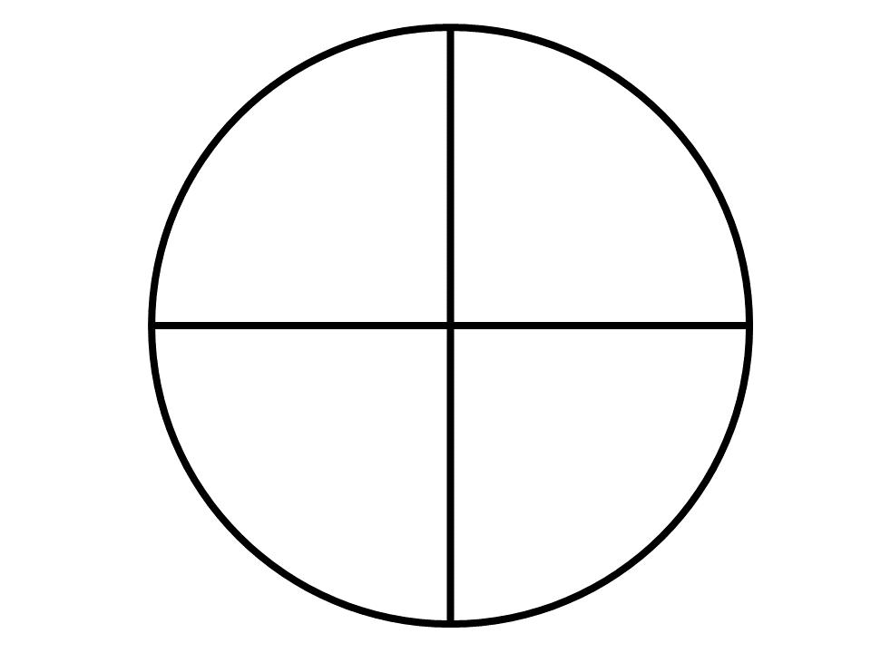
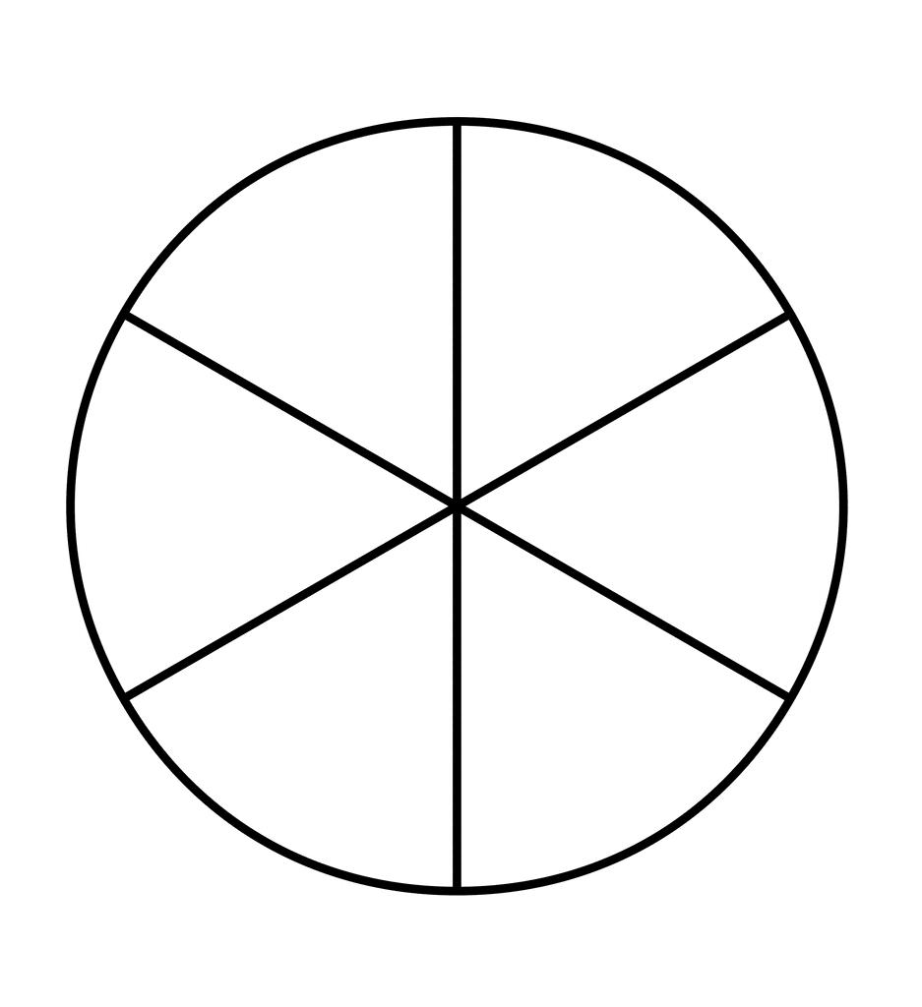
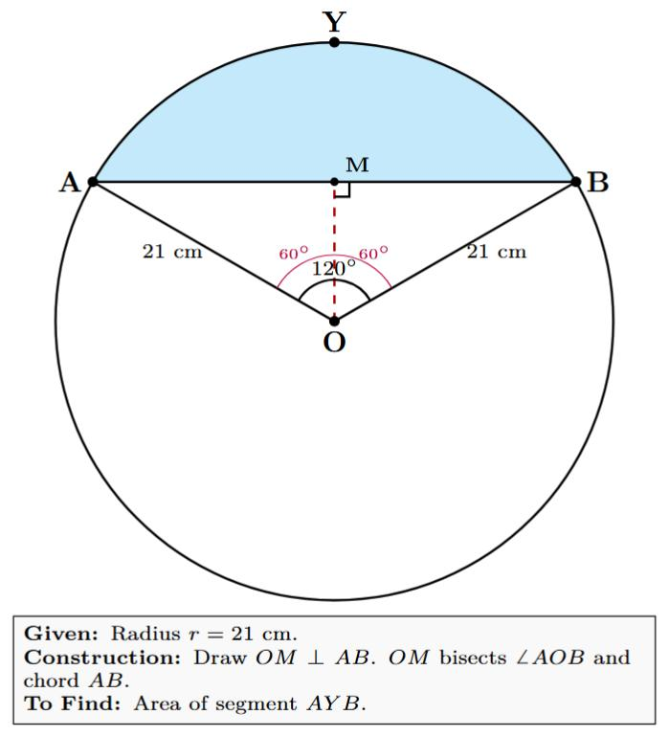

Main Classification
# Source: AI Source: Provided by: [Data Path: Persons Table -> ID Column: 1, Name_En Column: Motasem Essam] -> From: [ChatGPT] on [7/25/2026]
The following is a practical, descriptive classification, not a universally standardized mathematical taxonomy. Some types overlap because the same circular figure may be decomposed using multiple methods.

1. Sector-Based Circular Decomposition
# Source: AI Source: Provided by: [Data Path: Persons Table -> ID Column: 1, Name_En Column: Motasem Essam] -> From: [ChatGPT] on [7/25/2026]
Divides a circular region into sectors using two or more radii.
Example: dividing a disk into four equal sectors, each with a central angle of ${90}^{∘}$.
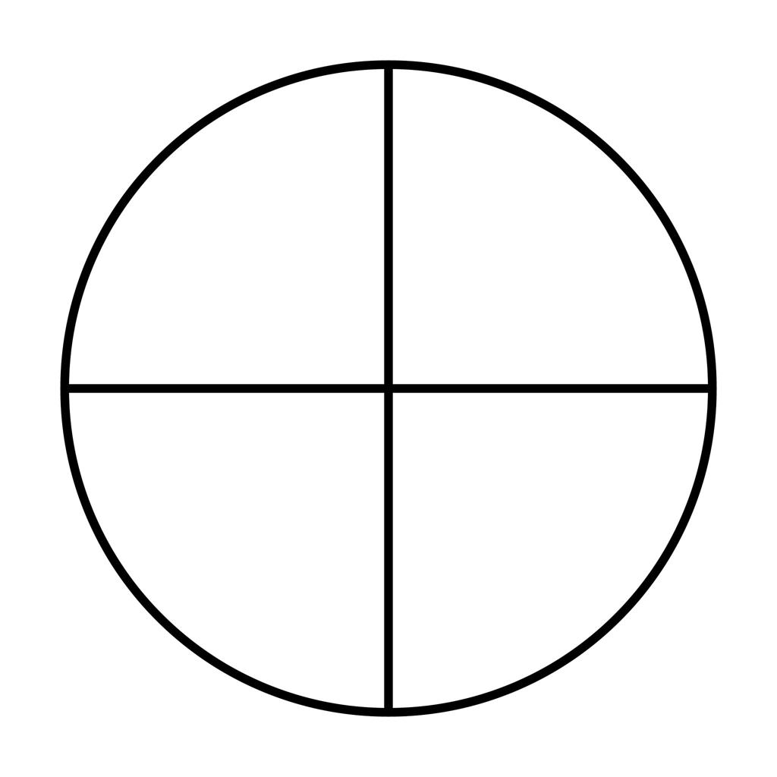
Detailed Explanation and Examples
Definition: A circular region is divided into sectors by drawing radii from the center to the circumference.
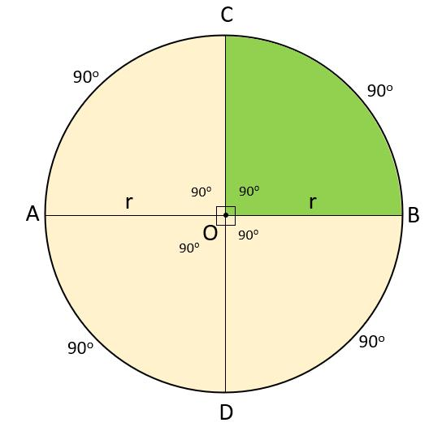
Example: A disk has radius $6$ units and is divided into four equal sectors.
The total area is
$$A=πr^{2}=36π$$
Each sector has central angle
$$θ=\frac{{360}^{∘}}{4}={90}^{∘}$$
Therefore, each sector has area
$$A_{\text{sector}}=\frac{36π}{4}=9π$$
Each sector has area $9π$ square units.
Important: Equal central angles in the same circle produce equal-area sectors.

2. Diameter-Based Circular Decomposition
# Source: AI Source: Provided by: [Data Path: Persons Table -> ID Column: 1, Name_En Column: Motasem Essam] -> From: [ChatGPT] on [7/25/2026]
Uses one or more diameters to divide a circular region into semicircles or smaller sectors.
Example: a diameter divides a disk into two equal semicircular regions.
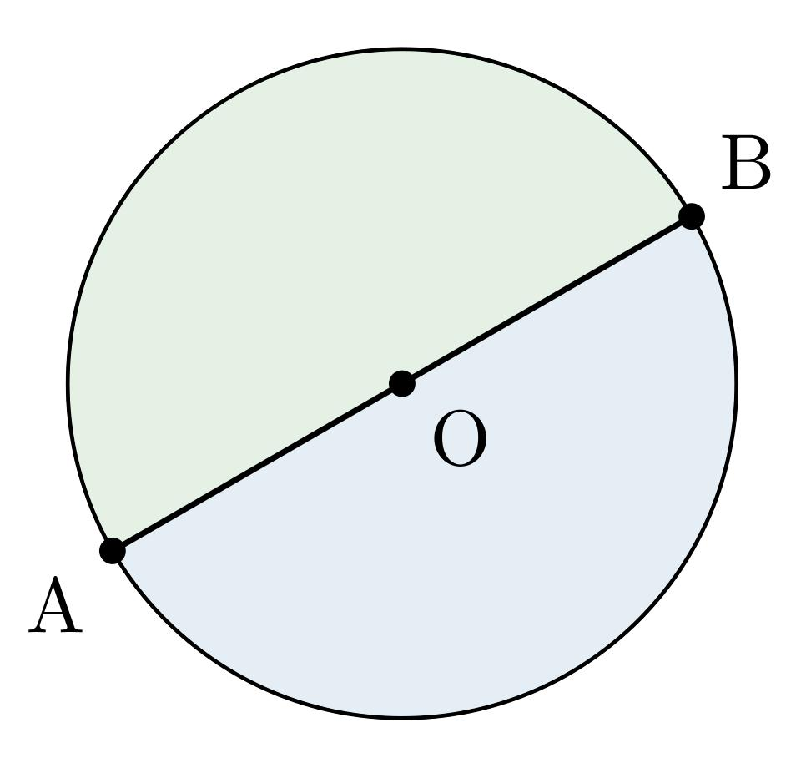
Detailed Explanation and Examples
Definition: A diameter divides a disk into two semicircular regions. Additional diameters can divide it into more sectors.
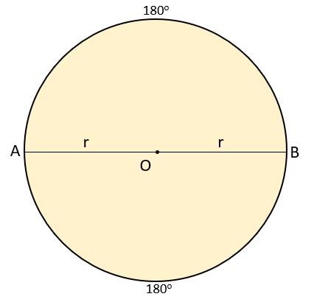
Example: A disk has radius $5$ units. A diameter divides it into two semicircles.
The area of the whole disk is
$$A=π{\left(5\right)}^{2}=25π$$
The area of each semicircle is
$$A_{\text{semi}}=\frac{12}{π}{\left(5\right)}^{2}=\frac{25π}{2}$$
Each semicircle has area $\frac{25π}{2}$ square units.
Important: A diameter passes through the center and has length $d=2r$. Any diameter divides the disk into two equal-area halves.

3. Chord-Based Circular Decomposition
# Source: AI Source: Provided by: [Data Path: Persons Table -> ID Column: 1, Name_En Column: Motasem Essam] -> From: [ChatGPT] on [7/25/2026]
Uses chords to divide a disk into circular segments.
Example: a chord divides a disk into a minor segment and a major segment.
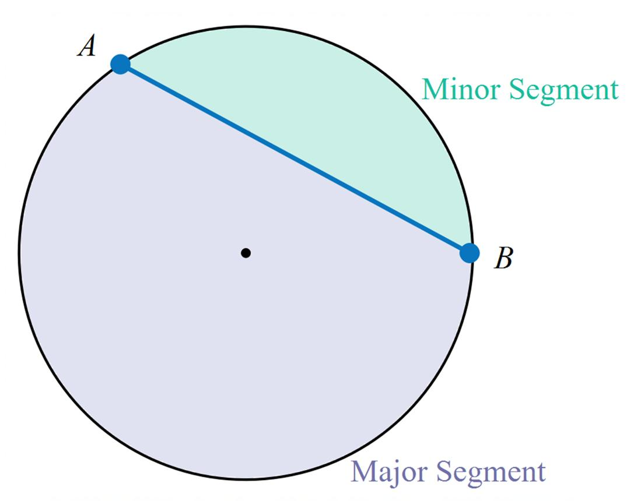
Detailed Explanation and Examples
Definition: A chord divides a disk into two circular segments, one minor and one major, unless it is a diameter, in which case the segments are equal semicircles.
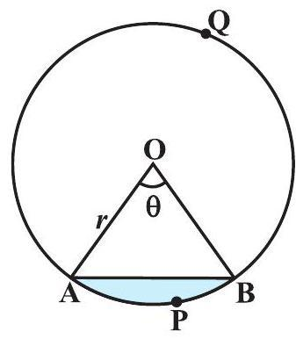
Example: A circle has radius $5$ units, and a chord subtends a central angle of ${90}^{∘}$. Find the area of the minor segment.
First, calculate the sector area:
$$A_{\text{sector}}=\frac{{90}^{∘}}{{360}^{∘}}π{\left(5\right)}^{2}=\frac{25π}{4}$$
The triangle formed by the two radii has area
$$A_{△}=\frac{12}{\left(5\right)}\left(5\right){\sin{90}}^{∘}=\frac{25}{2}$$
Therefore, the minor segment area is
$$A_{\text{segment}}=\frac{25π}{4}-\frac{25}{2}$$
$$\boxed{A_{\text{segment}}=\frac{25}{4}\left(π-2\right)}$$
Important: A circular segment is bounded by a chord and its corresponding arc. It is different from a sector, which is bounded by two radii and an arc.

4. Concentric-Circle Decomposition
# Source: AI Source: Provided by: [Data Path: Persons Table -> ID Column: 1, Name_En Column: Motasem Essam] -> From: [ChatGPT] on [7/25/2026]
Uses circles sharing the same center to create a central disk and surrounding annular regions.
Example: two concentric circles divide the larger disk into a smaller disk and an annulus.
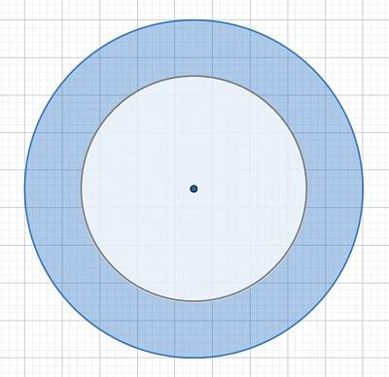
Detailed Explanation and Examples
Definition: Two or more circles sharing the same center divide a circular region into a central disk and surrounding annular regions.
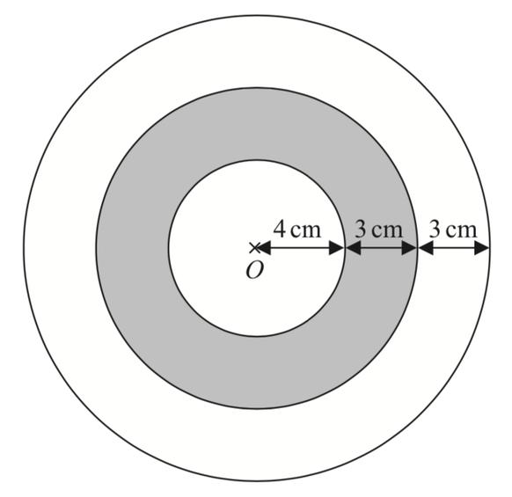
Example: Two concentric circles have radii $6$ and $3$ units.
The larger disk has area
$$A_{\text{outer}}=36π$$
The smaller disk has area
$$A_{\text{inner}}=9π$$
The annulus has area
$$A_{\text{annulus}}=36π-9π$$
$$\boxed{A_{\text{annulus}}=27π}$$
The original disk is decomposed into a central disk of area $9π$ and an annulus of area $27π$.
Important: The annulus is the region between the two circles; it does not include the interior of the smaller circle.

5. Annular Decomposition
# Source: AI Source: Provided by: [Data Path: Persons Table -> ID Column: 1, Name_En Column: Motasem Essam] -> From: [ChatGPT] on [7/25/2026]
Divides a ring-shaped region between two concentric circles into smaller regions, often annular sectors.
Example: dividing an annulus into four equal-angle annular sectors.
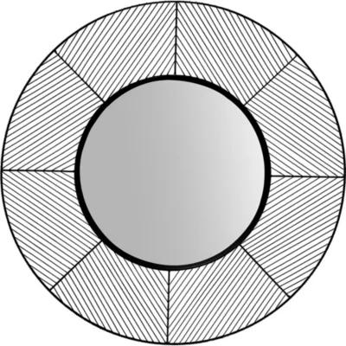
Detailed Explanation and Examples
Definition: An annulus is subdivided into smaller regions using radial segments or additional concentric circles.
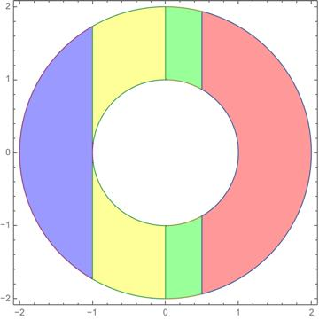
Example: An annulus has outer radius $6$ units and inner radius $4$ units. Four radii divide it into four equal-angle annular sectors.
The total annular area is
$$A=π\left(6^{2}-4^{2}\right)=20π$$
Each sector has angle ${90}^{∘}$, so its area is
$$A_{\text{sector}}=\frac{{90}^{∘}}{{360}^{∘}}\left(20π\right)$$
$$\boxed{A_{\text{sector}}=5π}$$
Each annular sector has area $5π$ square units.
Important: Equal angular divisions of the same annulus produce equal-area annular sectors.

6. Unequal-Sector Circular Decomposition
# Source: AI Source: Provided by: [Data Path: Persons Table -> ID Column: 1, Name_En Column: Motasem Essam] -> From: [ChatGPT] on [7/25/2026]
Divides a circular region into sectors with different central angles and therefore different areas when the radius is fixed.
Example: dividing a disk into sectors of ${60}^{∘}$, ${120}^{∘}$, and ${180}^{∘}$.
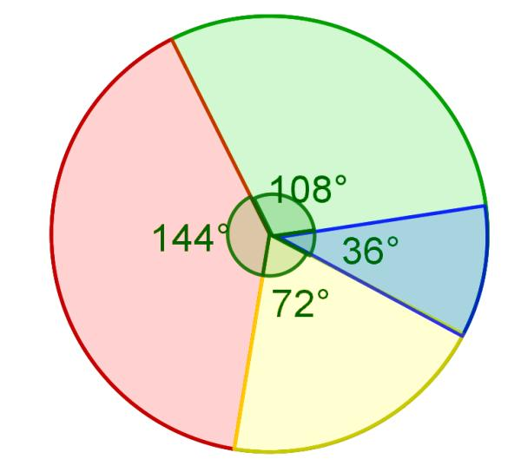
Detailed Explanation and Examples
Definition: A disk is divided into sectors with different central angles.
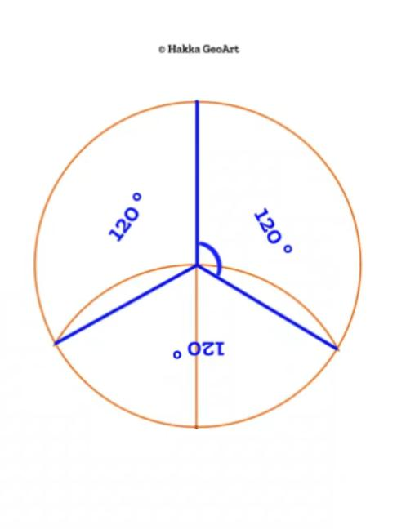
Example: A disk has radius $6$ units and is divided into sectors with central angles ${60}^{∘}$, ${120}^{∘}$, and ${180}^{∘}$.
The area of each sector is proportional to its central angle:
$$A_{\text{sector}}=\frac{θ}{{360}^{∘}}πr^{2}$$
Since $r=6$, the total area is $36π$.
- For ${60}^{∘}$:
$$A_{1}=\frac{60}{360}\left(36π\right)=6π$$
- For ${120}^{∘}$:
$$A_{2}=\frac{120}{360}\left(36π\right)=12π$$
- For ${180}^{∘}$:
$$A_{3}=\frac{180}{360}\left(36π\right)=18π$$
Verification:
$$6π+12π+18π=36π$$
Important: Unequal central angles produce unequal sector areas when the sectors belong to the same circle.

7. Multiple-Chord Circular Decomposition
# Source: AI Source: Provided by: [Data Path: Persons Table -> ID Column: 1, Name_En Column: Motasem Essam] -> From: [ChatGPT] on [7/25/2026]
Uses multiple chords to create several regions within a disk.
Example: two intersecting chords divide a disk into four regions.
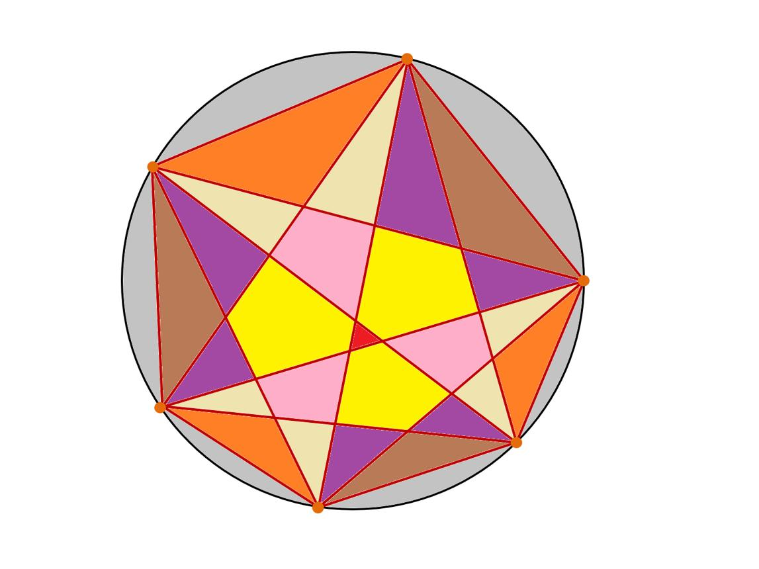
Detailed Explanation and Examples
Definition: Two or more chords divide a disk into multiple regions bounded by straight segments and circular arcs.
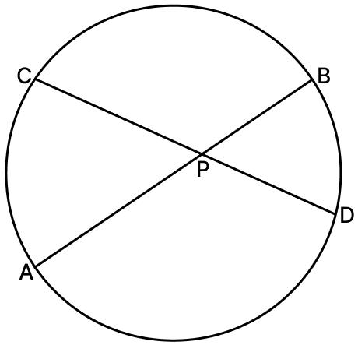
Example: Two distinct chords intersect inside a disk of radius $4$ units, creating four regions.
The total disk area is
$$A=π{\left(4\right)}^{2}=16π$$
If the four regions have areas $A_{1},A_{2},A_{3},A_{4}$, then
$$A_{1}+A_{2}+A_{3}+A_{4}=16π$$
The individual regions need not have equal areas.
Important: For $n$ distinct chords in general position—meaning no two are parallel and no three intersect at the same interior point—the number of regions inside the disk is
$$R=1+n+\frac{n\left(n-1\right)}{2}$$
For two chords,
$$R=1+2+\frac{2\left(1\right)}{2}=4$$
This formula assumes each chord crosses the interior of the disk and the intersections are all distinct.

8. Mixed Circular–Polygonal Decomposition
# Source: AI Source: Provided by: [Data Path: Persons Table -> ID Column: 1, Name_En Column: Motasem Essam] -> From: [ChatGPT] on [7/25/2026]
Divides a figure containing both straight and curved boundaries into simpler circular and polygonal regions.
Example: a rectangle with a semicircular end, decomposed into a rectangle and a semicircle.
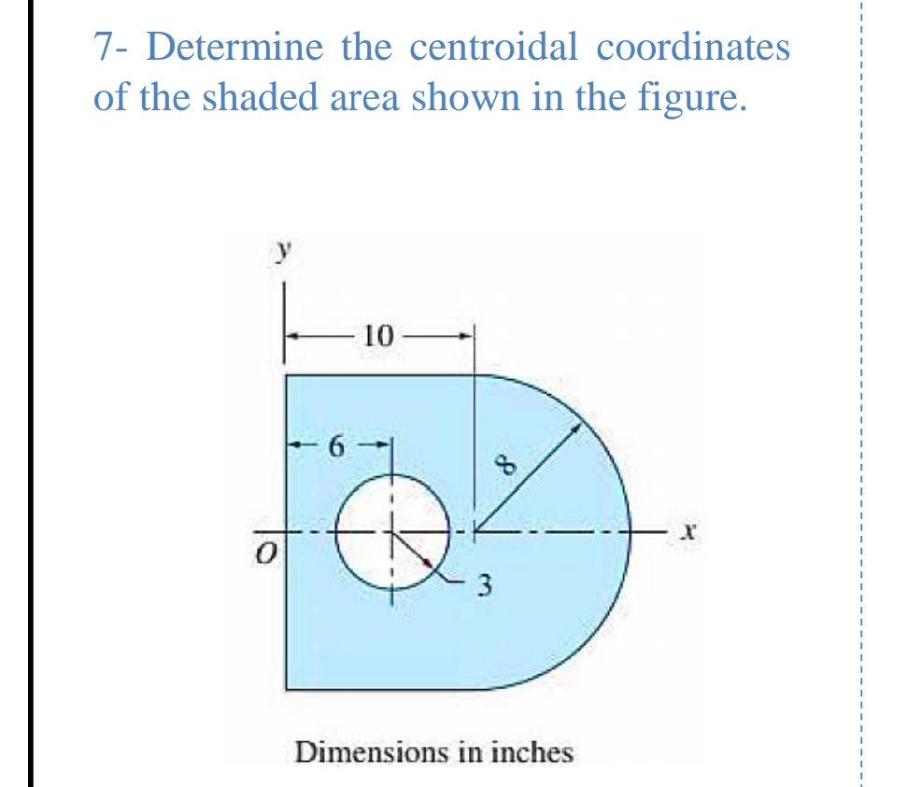
Detailed Explanation and Examples
Definition: A figure containing both straight and curved boundaries is decomposed into simpler circular and polygonal components.
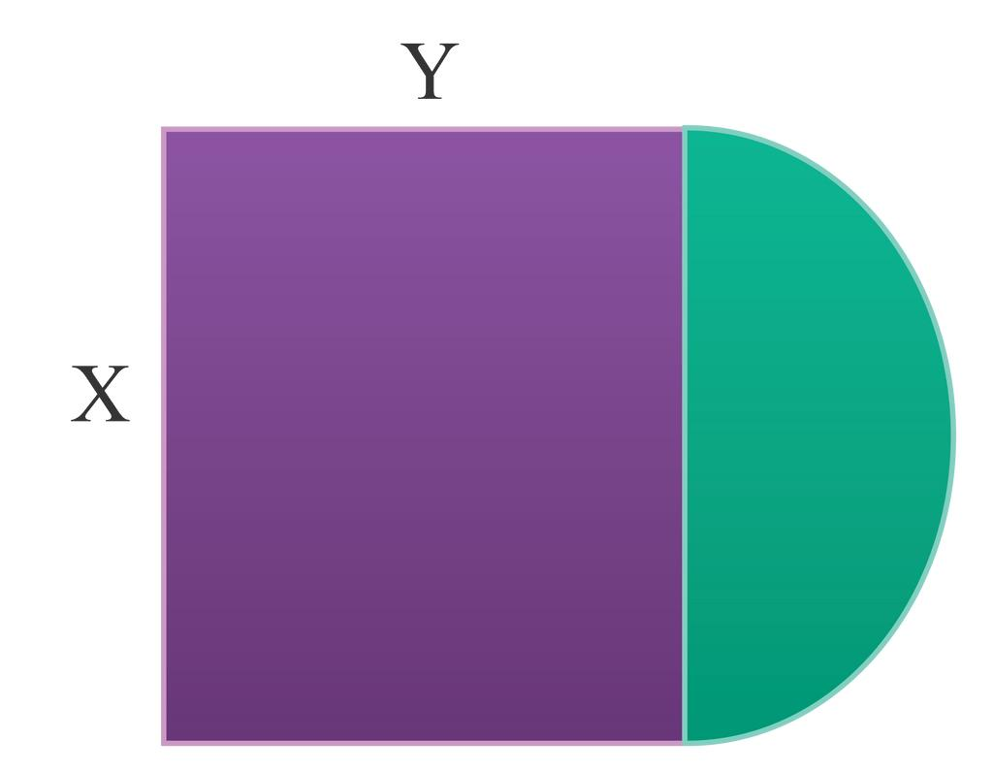
Example: A rectangle measuring $8×6$ units has a semicircle attached along one of its shorter sides. The semicircle has radius $3$ units.
The rectangle area is
$$A_{\text{rectangle}}=8\left(6\right)=48$$
The semicircle area is
$$A_{\text{semi}}=\frac{12}{π}{\left(3\right)}^{2}=\frac{9π}{2}$$
The total area is
$$\boxed{A=48+\frac{9π}{2}}$$
Approximately,
$$A≈62.14$$
square units.
Important: When calculating the outer perimeter, the shared side between the rectangle and semicircle is internal and must not be counted.

9. Overlapping-Circle Decomposition
# Source: AI Source: Provided by: [Data Path: Persons Table -> ID Column: 1, Name_En Column: Motasem Essam] -> From: [ChatGPT] on [7/25/2026]
Examines regions formed by intersecting circular disks.
Example: two overlapping disks create a lens-shaped intersection and two non-overlapping outer portions.
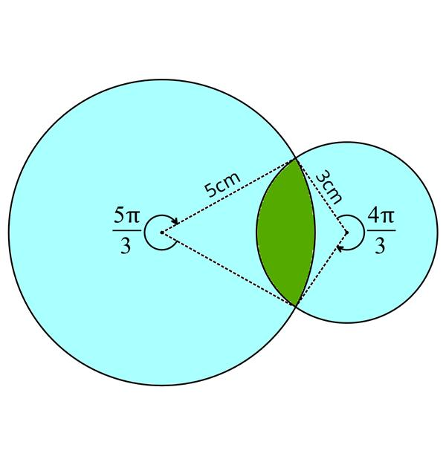
Detailed Explanation and Examples
Definition: Two or more circular disks overlap, creating an intersection region and portions belonging to only one disk.
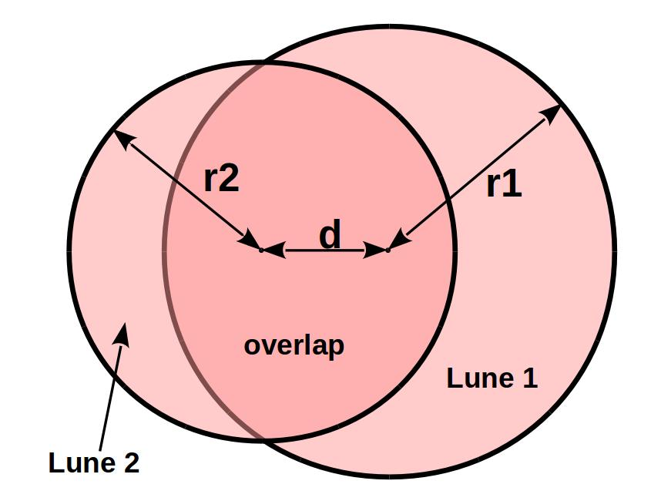
Example: Two circles have radius $5$ units and their centers are $6$ units apart.
The common lens area can be calculated using
$$A_{\text{lens}}=2r^{2}\cos^{-1}\left(\frac{d}{2r}\right)-\frac{d}{2}\sqrt{4r^{2}-d^{2}}$$
Substituting $r=5$ and $d=6$:
$$A_{\text{lens}}=50\cos^{-1}\left(\frac{35}{\backslash right})-24\right.$$
$$\boxed{A_{\text{lens}}≈22.36}$$
square units.
Important: When finding the area covered by the union of two overlapping disks, the common lens must be subtracted once:
$$A_{A∪B}=A_{A}+A_{B}-A_{A∩B}$$

10. Combined Circular Decomposition
# Source: AI Source: Provided by: [Data Path: Persons Table -> ID Column: 1, Name_En Column: Motasem Essam] -> From: [ChatGPT] on [7/25/2026]
Combines multiple circular methods, such as radial, chord-based, and concentric-circle subdivisions.
Example: a disk divided into a central circle and an annulus, with the annulus further divided into sectors.
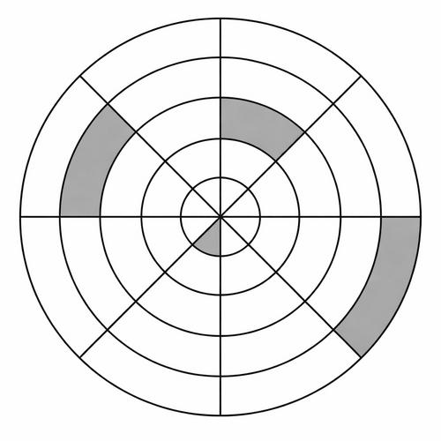
Detailed Explanation and Examples
Definition: Two or more circular decomposition methods are combined to divide a figure into several types of circular regions.
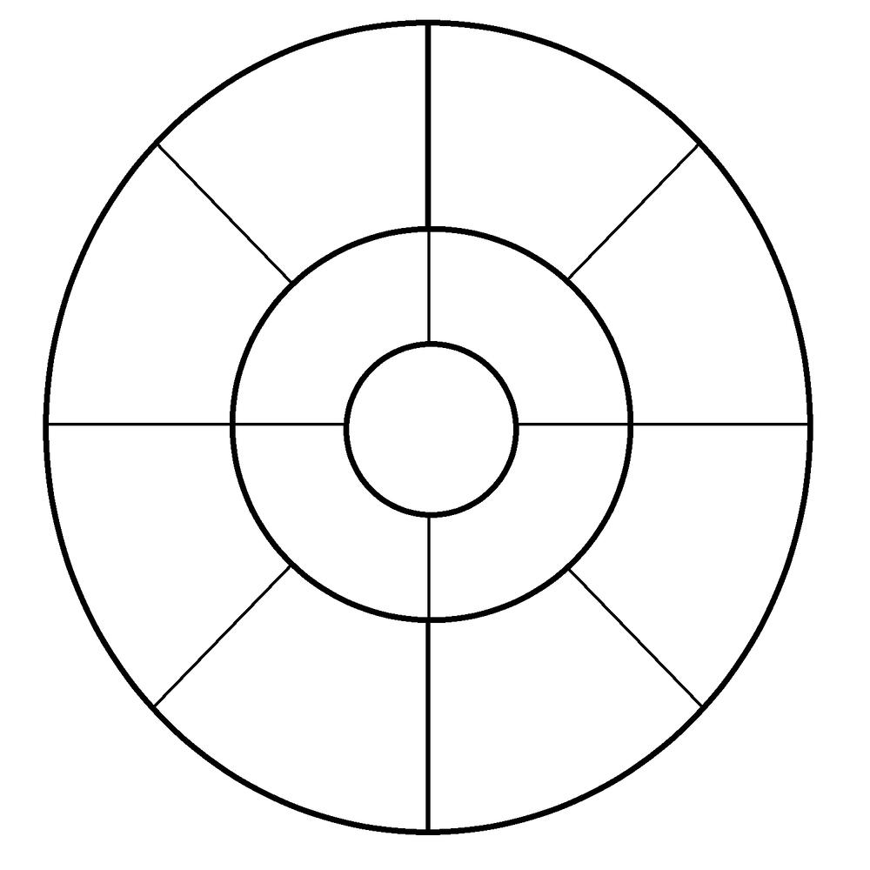
Example: A disk has outer radius $6$ units. A concentric circle of radius $3$ units separates it into a central disk and an annulus. Two perpendicular diameters divide the entire disk into four quadrants.
The central disk area is
$$A_{\text{center}}=π{\left(3\right)}^{2}=9π$$
The annulus area is
$$A_{\text{annulus}}=π\left(6^{2}-3^{2}\right)=27π$$
Each of the four annular sectors has area
$$A_{\text{annular sector}}=\frac{27π}{4}$$
The central disk is also divided into four equal sectors, each with area
$$A_{\text{central sector}}=\frac{9π}{4}$$
This combines concentric-circle decomposition and radial decomposition.

Key Formulas
# Source: AI Source: Provided by: [Data Path: Persons Table -> ID Column: 1, Name_En Column: Motasem Essam] -> From: [ChatGPT] on [7/25/2026]
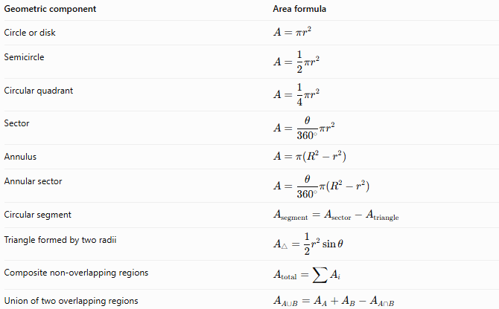
Geometric component | Area formula
Circle or disk | $$A=πr^{2}$$
Semicircle | $$A=\frac{1}{2}πr^{2}$$
Circular quadrant | $$A=\frac{1}{4}πr^{2}$$
Sector | $$A=\frac{θ}{{360}^{∘}}πr^{2}$$
Annulus | $$A=π\left(R^{2}-r^{2}\right)$$
Annular sector | $$A=\frac{θ}{{360}^{∘}}π\left(R^{2}-r^{2}\right)$$
Circular segment | $$A_{\text{segment}}=A_{\text{sector}}-A_{\text{triangle}}$$
Triangle formed by two radii | $$A_{△}=\frac{1}{2}r^{2}\sin{θ}$$
Composite non-overlapping regions | $$A_{\text{total}}=\sum{A_{i}}$$
Union of two overlapping regions | $$A_{A∪B}=A_{A}+A_{B}-A_{A∩B}$$
Here, $R$ is the outer radius, $r$ is the inner radius where applicable, and $θ$ is the central angle in degrees.

Comparison with Other Decomposition Types
# Source: AI Source: Provided by: [Data Path: Persons Table -> ID Column: 1, Name_En Column: Motasem Essam] -> From: [ChatGPT] on [7/25/2026]
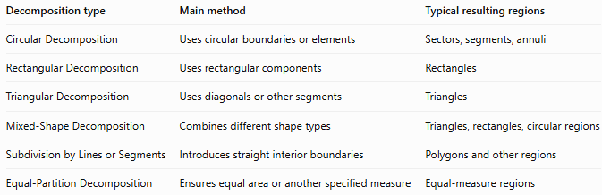
Decomposition type | Main method | Typical resulting regions
Circular Decomposition | Uses circular boundaries or elements | Sectors, segments, annuli
Rectangular Decomposition | Uses rectangular components | Rectangles
Triangular Decomposition | Uses diagonals or other segments | Triangles
Mixed-Shape Decomposition | Combines different shape types | Triangles, rectangles, circular regions
Subdivision by Lines or Segments | Introduces straight interior boundaries | Polygons and other regions
Equal-Partition Decomposition | Ensures equal area or another specified measure | Equal-measure regions
These classifications can overlap. For example, dividing an annulus into four equal sectors is both circular decomposition and equal-partition decomposition.

Classification Summary
# Source: AI Source: Provided by: [Data Path: Persons Table -> ID Column: 1, Name_En Column: Motasem Essam] -> From: [ChatGPT] on [7/25/2026]
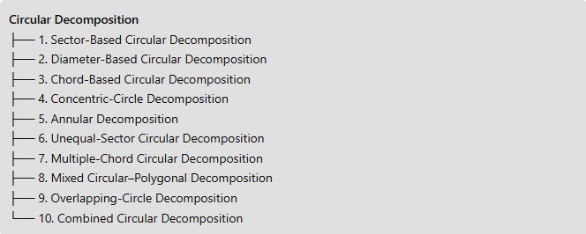
Circular Decomposition
├── 1. Sector-Based Circular Decomposition
├── 2. Diameter-Based Circular Decomposition
├── 3. Chord-Based Circular Decomposition
├── 4. Concentric-Circle Decomposition
├── 5. Annular Decomposition
├── 6. Unequal-Sector Circular Decomposition
├── 7. Multiple-Chord Circular Decomposition
├── 8. Mixed Circular–Polygonal Decomposition
├── 9. Overlapping-Circle Decomposition
└── 10. Combined Circular Decomposition

Key Points
# Source: AI Source: Provided by: [Data Path: Persons Table -> ID Column: 1, Name_En Column: Motasem Essam] -> From: [ChatGPT] on [7/25/2026]
- Circular decomposition simplifies figures containing circles, arcs, chords, sectors, and annuli.
- Radii and central angles are especially useful for calculating sector areas.
- Chords divide disks into circular segments, while concentric circles create annular regions.
- Overlapping circles require careful treatment of the intersection area to avoid double-counting.
- A composite figure's total area can be found by adding non-overlapping component areas or subtracting removed regions.
- The categories above are practical descriptive types; one figure may belong to several categories simultaneously.

Conclusion
# Source: AI Source: Provided by: [Data Path: Persons Table -> ID Column: 1, Name_En Column: Motasem Essam] -> From: [ChatGPT] on [7/25/2026]
Circular Decomposition is a geometric method of dividing circular or curved-boundary figures into simpler regions. Its main techniques include sector-based, diameter-based, chord-based, concentric-circle, annular, multiple-chord, overlapping-circle, and mixed circular–polygonal decomposition. It is especially useful for calculating areas and perimeters of circular figures and for simplifying complex composite shapes.

